BMS internal error

Author：Eason
Reviewer：Steven
FAQ\ BAT
Issue introduction
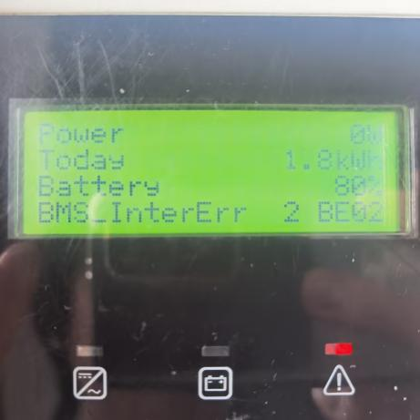
Confirmation of basic information
[Photo]SN number of the inverter and batteries.
[Photo]Inverter Screen.
Guidance for installer
Step1: Identify the specific fault location based on the number shown in the fault code on the inverter screen.

1——The fault occurred between the first battery and the BMS.
2——The fault occurred between the second battery and the first battery.
And so on...
Step2:If inverter display <BMS internal 2 error>
For HS50E&HS25/36.Remove BAT1, If the error disappears, reinstall it into the system—it may have been caused by a poor connection. If the error returns after reinstallation，remove the BAT1 and proceed to step5.
If remove BAT1 does not clear the error, reinstall BAT1 and remove the BAT2. If the error disappears, reinstall BAT2, it may have been caused by a poor connection. If the error returns after reinstallation, remove the BAT2 and proceed to step 5.
For T58, check the DIP switch according to the following instructions.
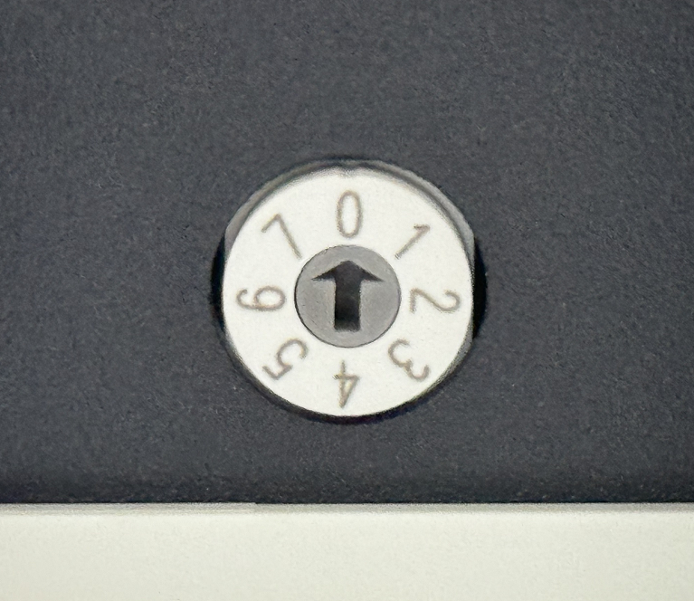
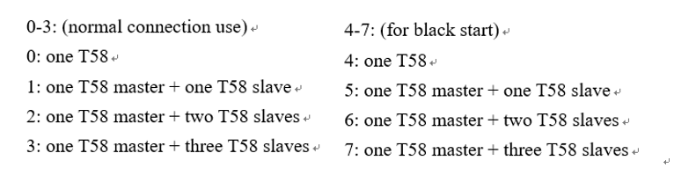
For BMS-Parallel Box-II, check the DIP switch according to the following instructions.
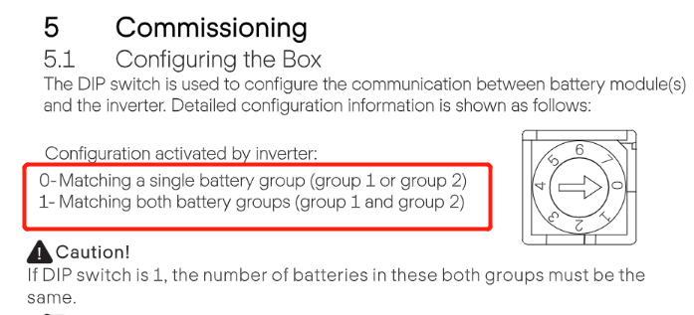
Instruction of BMS-Parallel Box-II DIP switch
Step3: Check the communication cable between master and slave, slave and slave. Ensure that the cables are connected tightly.
For T58:
Connection of T58 BMS | Communication connection of master and slave
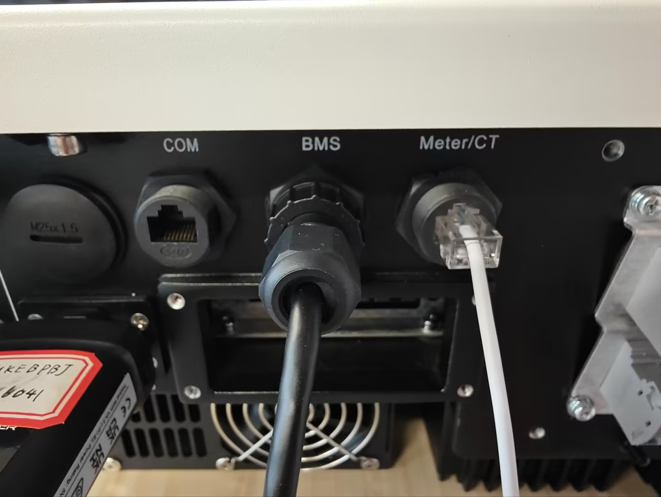 | 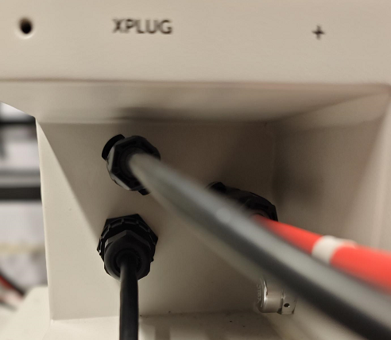
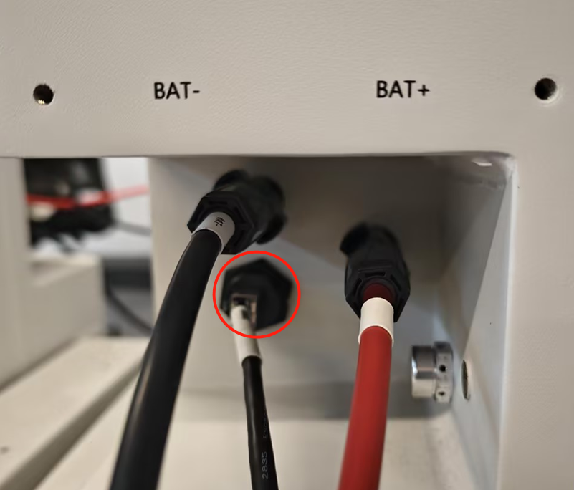 | 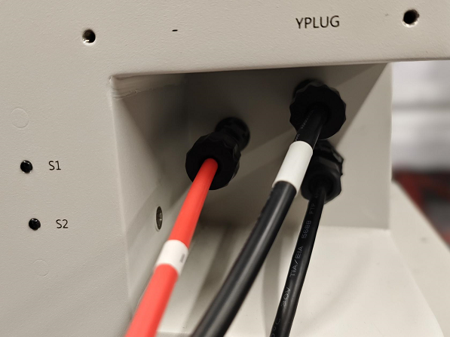
For T30:Communication cable of BMS should be connected to the BMS port of the inverter.
Connection of T58 BMS | Master and slave, slave and slave
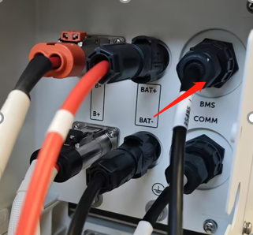 | 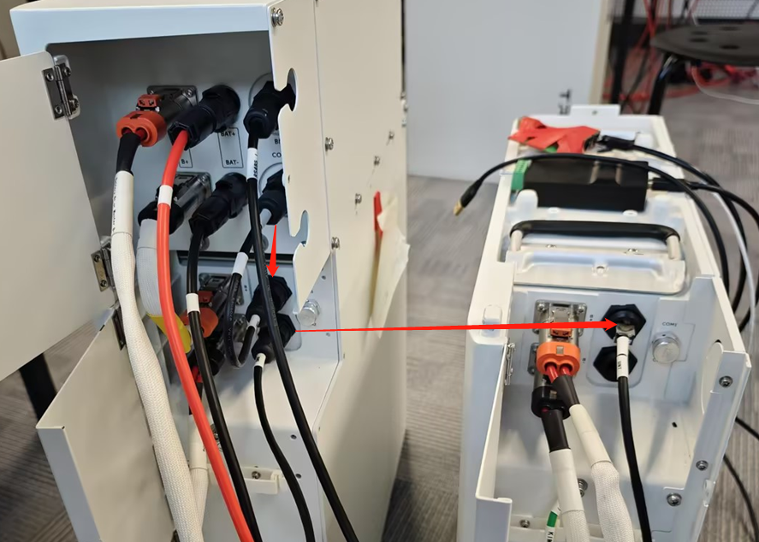
If connection is correct, check for damage to communication ports. Ensure internal pins are intact.
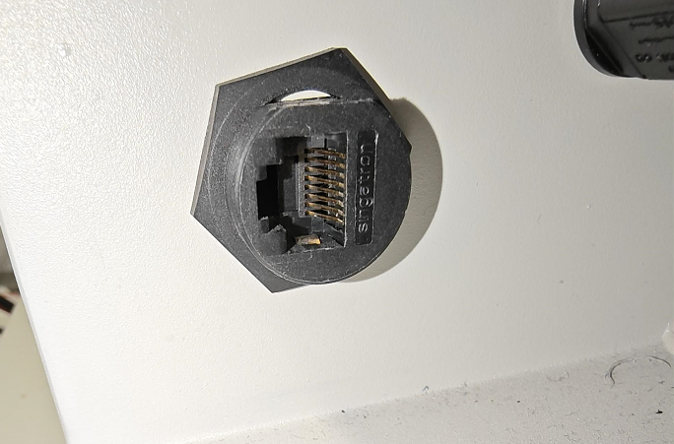
Step4: Check the status indicators of batteries. For T58, in the normal state, the Master status indicators are always green and the slaves flash green every five seconds.
Status indicators of T58 BMS | Status indicators of T58
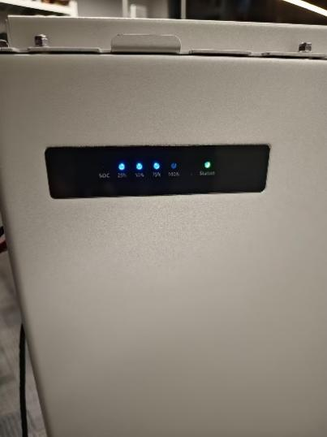 | 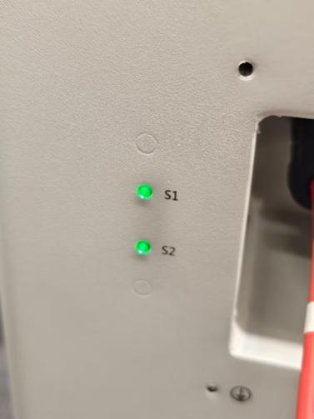
For T30, the BMS status indicators are always green and the slaves flash green every five seconds.
Status indicators of T30 BMS | Status indicators of T30 slave
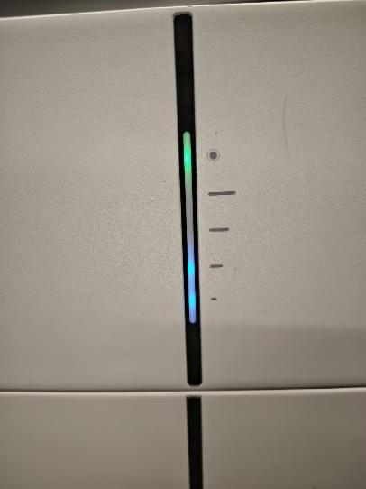 | 
If the status indicators of the slave are abnormal, remove it then connect other batteries and start the system to see whether the error is reported.
Step5: Measure the voltage of the fault battery individually.
For HS50E&HS25/36, don't forget to place the battery on the base before measuring the voltage, otherwise the result will be incorrect.
Measure the voltage of HS50E | Measure the voltage of HS25/36
If the measured voltage is between 50V and 90V, contact the SolaX team for recharging. If the voltage is below 50V, replace the battery.  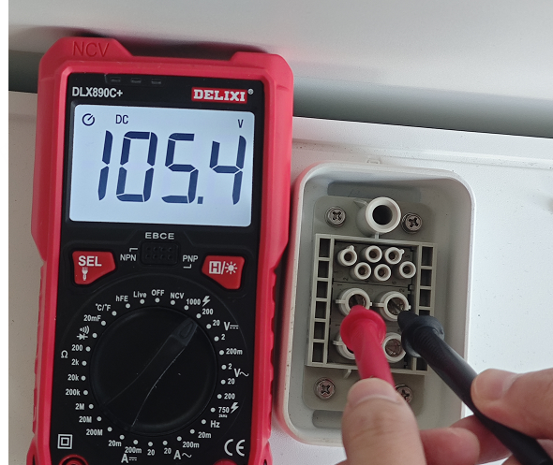 | If the measured voltage is between 30V and 50V, contact the SolaX team for recharging. If the voltage is below 30V, replace the battery.  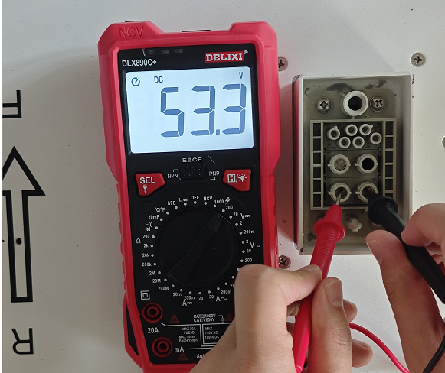
ForT58&T30, If the error is still reported, measure the voltage of each battery.
Measure the voltage of T58 | Measure the voltage of T30
Use the red pen and black pen of the multimeter to measure whether the voltage on the battery side is normal. Normal single T58 battery has a rated voltage of 115.2V, the operating voltage range of 100-131V.  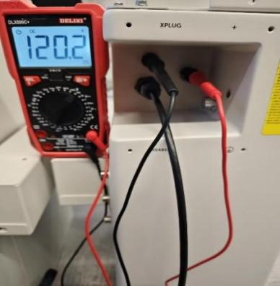 | Use the same method to measure the voltage of T30, insert the pen into the round hole to the right of the terminal. A normal T30 single battery has a rated voltage value of 102.4V and the operating voltage range of 90-116V.  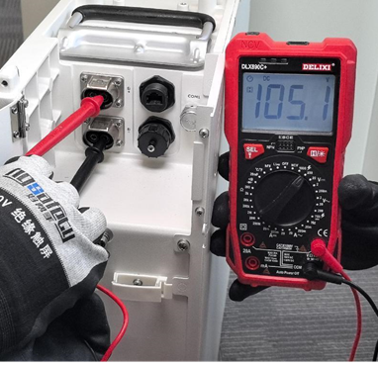
If the voltage of each battery is above 40V and the total system battery voltage meets the inverter's minimum battery voltage requirement, use the inverter's force charging mode to recharge the batteries.
Setting path: Work mode→Work mode→Manual→Force charge
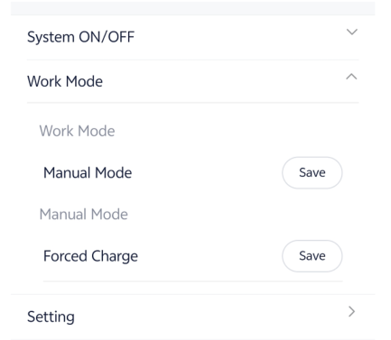
If the inverter is unable to complete force charging, and the voltage of a single battery is already below 40V, please refer to the attached T-BAT Charger user manual to perform forced charging on the battery.
https://km.solaxpower.com/index.html#doc/enterprise/362472
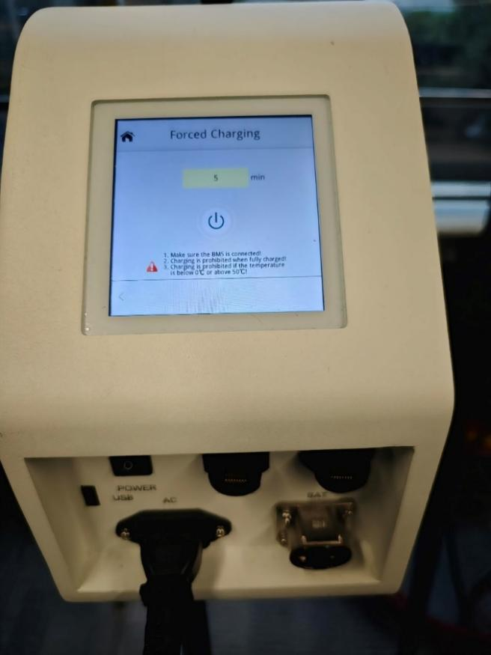
If voltage of each battery is between normal range, measure the total voltage of all batteries. Make sure that the voltage is around the normal value.
Table 2 Measure the total voltage of batteries
Measure the total voltage of T58 | Measure the total voltage of T30
Insert the red pen to the BAT+ of the master battery，the black pen to the BAT-. Normal T58 battery total voltage is 115.2V * number of batteries.  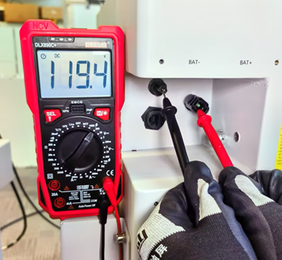 | Insert the red pen to the BAT+ of the BMS，the black pen to the BAT-. Normal T30 battery total voltage is 102.4V * number of slaves.  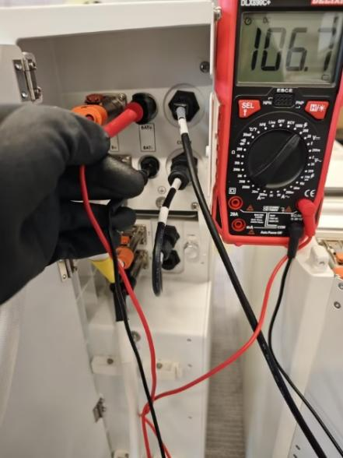
Information check list
If you have completed the above <Guidance for installer>, and the problem is still not solved, please collect the following troubleshooting information and send them to the R&D.
1. [Photo]SN number of the inverter and batteries.
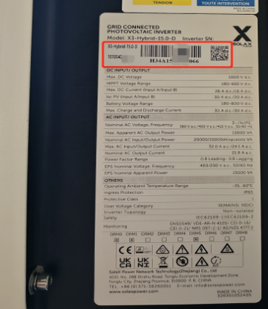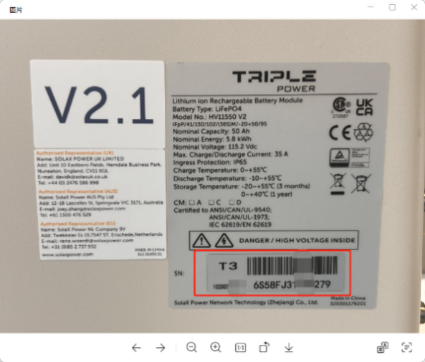
2. [Photo]Inverter screen.

3. [Photo]DIP switch（T58 &BMS parallel box）

4. [Photo]Communication connection of batteries


5.[Photo]Communication port.

6. [Video]Scintillation mode of status indicator.
7. [Photo]The voltage of each battery.
Measure the voltage of HS50E | Measure the voltage of HS25/36
 | 

Measure the voltage of T58 | Measure the voltage of T30
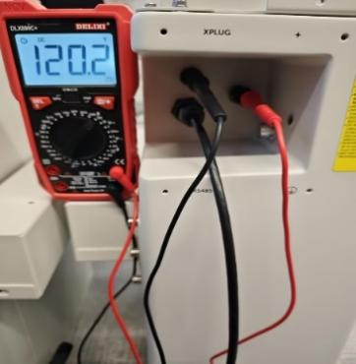 | 
8. [Photo] The total voltage of batteries.
Measure the total voltage of T58 | Measure the total voltage of T30
 | 